iPad Usage

Expectations | Consequences
- Bring your charged iPad to class each day  - Check school email daily  - Use iPad for academic purposes  (iPad is not to be used for gaming, texting, social networking, “snapchatting”, etc while in class)  - Only use your iPad in other classes with teacher permission  - Maintain A,B, or C grade in our class  - Follow all school rules, including Acceptable Use Policy | (For failing to meet expectations)  - Loss of gaming & Internet privileges.  - Confiscation of iPad.  - Referral to Dean’s office.
Words of Wisdom
Remember, using your iPad is a privilege, not a right. Buy insurance for your iPad.
Do not lend your iPad to others. Take good physical care of your iPad.

Homework:
Complete the McDonald iPad Expectations Google form to acknowledge your understanding.
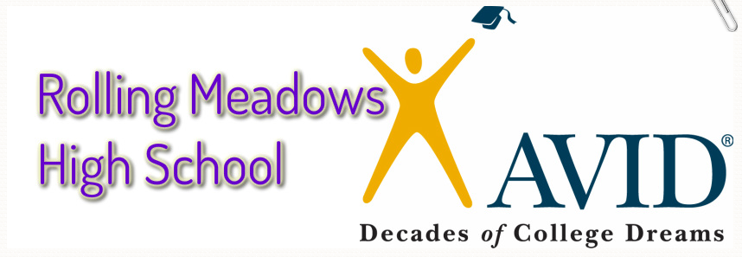

AVID Elective – Sophomore Year
Mrs. Carolyn McDonald
Carolyn.mcdonal@d214.org 847-718-5768

Course Objective:
To teach academic and social skills to help students develop the habits and behaviors needed to succeed in rigorous curriculum through:

WICOR: Writing, inquiry, collaboration, organization, & reading

Guest speakers, college visits, and research-based projects

Grading Categories |  | Grading Scale
Tutorials 30%  Binders 30%  Coursework 30%  Final Exam 10% |  | A = 90-100%  B = 80-89%  C = 70-79%  D = 60-69%  F = 59% & below

What’s my grade?
Grades can be checked online at: https://hl.d214.org/HomeLogic/

Grading Policy
Collected assignments will be entered into HomeLogic within two weeks. Some work, such as essays and projects, require significant grading time and may not be entered into HomeLogic for several weeks.

If a student is missing an assignment, the grade will appear as MIS, indicating that the assignment has not been turned in but may be completed for credit. The MIS code counts the task/assignment as a zero until the task/assignment is turned in and graded. Students may make up work during the quarter in which it is assigned. Points will be deducted if assignments are late – minus 10% of the total points possible for each day late.
Not all work collected may be given a grade in the system; some assignments are designed purely as practice for the student or as formative assessment and may not appear in HomeLogic. If parents have questions regarding grades, they are encouraged to email me at carolyn.mcdonal@d214.org.

Homework Day 1

Student Name
Student Class Number
Parent Name
Parent Phone Number
Parent Email Address

I had a discussion with my child about his/her AVID Elective class and I understand how I can contact Mrs. McDonald with any questions or concerns.

Parent Signature

Parent Comments or Questions?

